CSci 242: Algorithms and Data Structures **Fall, 2019**

Instructor: Dr. M. E. Kim Date: September 27th, 2019

Due: by the end of day, October 7th (Mon.), 2019. Name : Elena Corpus

**Home Assignment 3: 60 points + 140 (implementation) + 10 (Optional)**

Q1. [10] **Balanced Binary Search Tree (Psuedocode)**

Write an algorithms ***min*(T)** and ***max*(T)**, which return the key-value pair (*k*, *e*) with *smallest* and *largest* key, respectively, in O(log *n*) time in the *balanced binary search tree, T*.

min(node root)

Node k = root

While k.left is not null then

K = k.left

K = return(k.data)

Max(node root)

Node E = root

While e.right is not null then

E = e.left

E = return (E.data)

Print (k,e)

Q2. [10] **AVL Tree**

Consider the insertion of the following keys (in the given order) into an initially empty AVL tree:

15, 45, 55, 35, 25, 40, 10. Draw the final AVL tree.

35

/ \

15. 45

/ \ / \

10 25 40 55

Q3. [10] **AVL Tree**

Draw the AVL tree resulting from the removal of the key 40 from the AVL tree of Figure below.

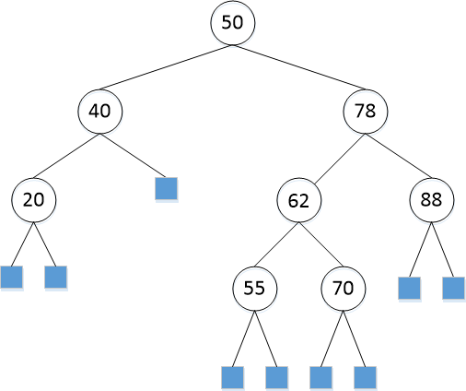

Removal of 40

62

/ \

50 78

/ \ / \

20 55 70 88

Q3B. [70] (code)

For Q2 – Q3, implement the operations (insert, remove, restructure, etc.) of AVL tree in Python or in Java. Print the resulting tree from the root in the following format:

(a key of node: a depth of node, a key of parent, a key of left-child, a key of right-child)

e.g.) (50: 0, null, 40, 78)

Since AVL tree is a balanced Binary Search Tree, you may be able to reuse your Java codes of certain operations from HW 2.

Include the image of your output to the corresponding question.

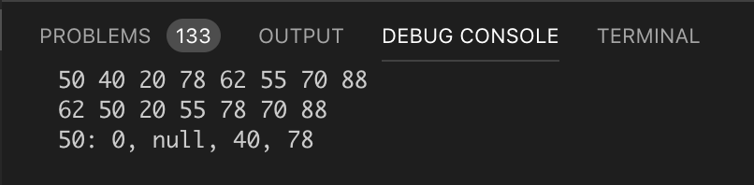

Q4. [10] **AVL Tree**

Professor Amadeus claims that the order of keys to be inserted into an AVL tree does not matter; i.e. the same tree always results every time. Give a counter example that contradicts Prof. Amadeus’s claim.

Amadeus claim holds true for a tree with a single node. But it fails in most, if not all the other cases. Consider a tree with 2 elements {1,2}. The tree with elements inserted in order 1,2 :

1

\

2

But with the tree with the elements inserted in order 2,1 :

2

\

1

The examples show that the trees are not the same even with the same elements, and thus contradicting Amadeus’s statement.

Q5. [Optional, 10] **AVL Tree**

Draw an example of an AVL tree such that a single remove operation could require Θ(log *n)* trinode restructurings (i.e. rotations) from a leaf to the root in order to restore the height-balance property.

Original :   
 10

/ \

4 20

\ / \

5 15 30

/ \

14 31

Single Remove of 17:

20

/ \

10 30

/ \ \

5 15 31

/

14

Q6. [20] **Red-Black Tree**

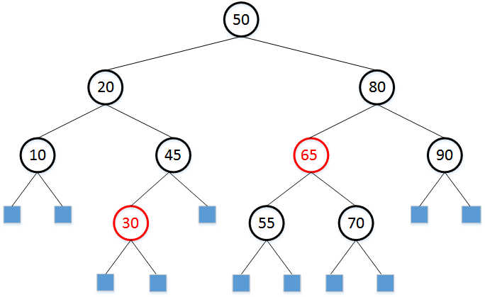

1. [10] Draw the Red-Black tree after each insertion of 35 and 40 into the given RB-tree above.

Insertion of 35 :

50

/ \

20. 80

/ \. /. \

10 35. 65 90

/ \ / \

30 45 55 70

Insertion of 40

50

/ \

20 80

/ \ / \

10 35 65 90

/ \

30 45

/

40

1. [10] In the given Red-Black Tree above, draw the resulting Red-Black tree after deleting 10..

Deletion of 10

50

/ \

35. 80

/ \ / \

20 45 65 90

\ / / \

30 40 55 70

Q6B. [70](Code) Similarly, implement the operations of Red-Black tree in Q6. Print the resulting tree in the form of:

((a key of node, color), depth, (a key of parent, color), (a key of left-child, color), (a key of right-child, color))

e.g.) ((80, B), 1, (50, B), (65, R), (90, B))

Since RB-tree is a balanced Binary Search Tree, you may be able to reuse your Python/Java codes of certain operations from HW 2.

Include the image of your output to the corresponding question.